NIRD (Network Insurance Renewal Development)

Test Plan

VERSION: **0.1** / 3rd Mar 2021

IMPORTANT - PLEASE READ

Intellectual property

Copyright © 2009-2021, Steadfast Technologies Group Holdings Pty Ltd, its related bodies corporate and their licensors. All rights reserved. You must not copy, adapt or communicate this document, or exercise any other rights in the copyright, without our prior written permission.

Steadfast Technologies Group Holdings Pty Ltd, its related bodies corporate and their licensors also own all trademarks represented in this document. You must not use these trademarks without our prior written permission.

Confidentiality

This document contains confidential information and must only be used for the purposes for which it was provided. Under no circumstances may this document, or any part of it, be disclosed or otherwise provided to any third party.

Take care

Care should be taken when using or relying on this document. The information in this document is subject to change and you should ensure that you have the most current version. Any calculations and data shown in any examples are for presentational purposes only and should not be relied on. Names and addresses mentioned in examples are fictitious.

Contents

1 Introduction 1

1.1 Document Purpose 1

1.2 Objectives 1

2 Test Scope 1

2.1 In Scope 1

2.1.1 Requirements 1

2.1.2 Cross Platform / Browser testing 1

2.2 Out of Scope 2

2.3 Key Milestones 2

2.4 Dependencies 3

2.5 Assumptions 3

2.6 Risks & Issues 3

3 Test APPROACH 4

3.1 Functional testing approach in Sandpit / UAT 4

3.2 Regression testing approach 4

3.3 Entry and Exit Criteria 5

3.3.1 Entry Criteria 5

3.3.2 Exit Criteria 5

3.4 Test Cases 6

3.5 Test Results 6

3.5 Test Completion Report 7

4 Defects Management 8

5 Environment Requirements 9

5.1 Tools 9

6 Appendix A 10

6.1 Defect Severity Definitions 10

7 Document Management 11

7.1 Version Management 11

7.2 Distribution 11

7.3 Related Documents 11

* 1. Glossary 11

# Introduction

## Document Purpose

The purpose of this document is to define the scope, approach and high-level objectives required for testing both functional and non-functional fixes / changes on NIRD project listed in ‘In Scope’ section

The intended audience for this document is the **Steadfast Technologies Team**

## Objectives

The objective of the testing phase is to ensure that all system and process changes have been implemented as per the business requirements for the NIRD project (Requirement Description listed in ‘In Scope’ section) as part of the current release.

# 

# Test Scope

The scope and areas of testing as part of this release has been listed below.

## In Scope

### Requirements

| **Application / Module / Functionality** | **Requirement**  **Reference** | **Requirement** | **Cross Browser/OS testing required?** | **Test Objectives** |
| --- | --- | --- | --- | --- |
| NIRD | **R.1** | **Two Forms – Management Liability and Cyber Security forms (one for each policy)** | Yes | Validate the access to 2 forms. |
| R.1.1 | The Broker must be able to select the Management Liability Proposal Form. | Yes | Validate the access to this form. |
| R.1.2 | The Broker must be able to select the Cyber Security Questionnaire. | Yes | Validate the access to this form. |
| R.1.3 | There is only one form per policy. This form will be used for new applications and renewals. | Yes | Validate the form is the same for each policy. |
| R.1.4 | Each form should have a title. | Yes | Validate forms’ title. |
| R.1.5 | Each form should display the year it applies to. | Yes | Validate policy’s year in the form |
| **R.2** | **Accessing Forms via ‘My Brokerage’** | Yes | Validate the forms must be accessed via My Brokerage |
| R2.1 | The Broker must be able to access the forms via ‘My Brokerage’ on the Broker website (Sitecore). | Yes | Validate Broker must login successful to Broker website to navigate to forms. |
| R2.2 | Only Principals of Broker accounts must have access to these forms in ‘My Brokerage’ (based on Salesforce permissions). | Yes | Validate only Principal Brokers who has the correct granted credential can access to My Brokerage page. |
| R2.3 | The Broker Forms are accessed by the Brokers under the existing heading of ‘Group Insurances’ in ‘My Brokerage’. | Yes | Validate forms’ navigation is under My Brokerage > Group Insurances menu. |
| **R.3** | **Form Design & Style** | Yes | Validate form’s design & style |
| R.3.1 | The design of the forms must be consistent with the current Broker website. | Yes | Validate forms’ design follow the Steadfast [Broker Website Style Guidelines](https://projects.invisionapp.com/share/Q2Q3FMQTSAP#/screens). |
| R.3.2 | The forms are to be based off the ‘Broker Assist’ style. | Yes | Validate the forms same as the ‘Broker Assist’ style. |
| R.3.3 | Design of the forms will follow the Steadfast Broker Website Style guidelines for the Broker website. | Yes | Validate forms’ design follow the Steadfast [Broker Website Style Guidelines](https://projects.invisionapp.com/share/Q2Q3FMQTSAP#/screens). |
| R.3.4 | The forms must include Help text (hover or icon pop-up) for some questions identified as requiring additional information to assist with completing questions. | Yes | Validate Help icon works correctly. |
| R.3.5 | Standard Broker website functionality should apply for validations, mandatory fields etc. | Yes | Validate validations and mandatory fields on the forms based on existing Broker website’s function. |
| **R.4** | **Filling in and Saving Forms (in-progress)** | Yes |  |
| R.4.1 | The Broker can only complete one form per policy at a time for that year/policy period. | Yes | Validate a policy can be submitted only once. |
| R.4.2 | A form should pre-populate with pre-defined fields from Salesforce (Live data). | Yes | Validate on a New form or Saved form, Salesforce pre-populated fields should display correctly. |
| R.4.3 | The Pre-populated fields from Salesforce (Live data) must be read-only. | Yes | Validate on a New form or Saved form, Salesforce pre-populated fields should be read-only. |
| R.4.4 | The Broker must be able to Save a form in-progress to Salesforce. | Yes | Validate a form which status is New can be saved. |
| R.4.5 | An “i” (for information) icon, similar to help text, should be next to the read-only pre-populated fields informing the Broker if they need to update their details they must do so through ‘My Brokerage’. | Yes | Validate the displaying of “i” icon. |
| R.4.6 | All data saved in fields on the form (including pre-populated from Salesforce Live data) should be saved as new objects in the Salesforce database, timestamped, kept for 7 years then archived. | No | Validate new objects are created in Saleforce for a Saved form. |
| R.4.7 | The Broker can overwrite data previously entered in a Saved form (to the new Salesforce objects for that year). | No | Validate data which previously entered can be overwritten in Salesforce for a Saved form. |
| R.4.8 | The Broker should be able to Clear the form. | Yes | Validate the form can be cleared. |
| R.4.9 | The Broker must be able to retrieve a saved form by clicking on the form link in ‘My Brokerage’ under ‘Group Insurances’. | Yes | Validate a Saved form can be retrieved by clicking its link under Group Insurance list. |
| **R.5** | **Signing a Declaration** | Yes |  |
| R.5.1 | The Broker must be able to tick a ‘Declaration’ box before submitting the form | Yes | Validate ‘Declaration’ box is required. |
| **R.6** | **Submitting a Form Online** | Yes |  |
| R.6.1 | The Broker must be able to Submit a form online. | Yes | Validate Submit button works correctly. |
| R.6.2 | Once a form is submitted it must be recorded as having a status of submitted in Salesforce. | No | Validate a submitted form having a “Submitted” status in Salesforce. |
|  | R.6.3 | Fields must be validated prior to submitting the form e.g. mandatory fields. | Yes | Validate fields’ validation on the forms. |
|  | R.6.4 | The Broker cannot submit a form past the ‘cut-off’ date. | Yes | Validate a form can’t be submitted if it pass the cut-off date. |
|  | R.6.5 | The Broker must be able to edit a submitted form up to a ‘cut-off’ date. | Yes | Validate a submitted form can be edited if it does not pass the cut-off date. |
|  | R.6.6 | Once the ‘cut-off’ date has transpired the Broker can view the form as read-only. | Yes | Validate the form will be read-only if the cut-off date has transpired. |
|  | R.6.7 | The ‘cut-off’ off date must be configurable at Broker level in Salesforce to facilitate ad hoc changes in cut-off dates for individual Brokers. | No | Validate the cut-off date config in Salesforce. |
|  | R.6.8 | The Declaration tickbox is cleared when the Broker clicks to edit a submitted form. | Yes | Validate Declaration tickbox will be cleared when the Broker edits a submitted form. |
|  | R.6.9 | The submitted status in Salesforce must be removed when the Broker clicks to edit a form. | No | Validate submitted status in Salesforce must be removed when the Broker edits a form. |
|  | R.6.10 | The Broker must receive a confirmation message displayed on-screen advising their form has been submitted. | Yes | Validate confirmation message displaying when a form is submitted. |
|  | **R.7** | **Salesforce Requirements** | **No** |  |
|  | R.7.1 | The Broker Services user must be able to retrieve the form data from Salesforce in CSV format. | No | Validate the CSV file extraction from Salesforce. |
|  | R.7.2 | The Broker Services user must be able to identify in Salesforce if a Broker has submitted a form and run a report that exports to Excel | No | Validate the existing of the Broker Services user after a form is submitted and validate the Excel report from Salesforce. |
|  | **R.8** | **Workflow Post Submit** | **Yes** |  |
|  | R.8.1 | When the Broker submits a form, an email is triggered to the Broker confirming their form has been received and a link to view the form on the Broker website. | Yes | Validate an email will be sent to Broker after a form is submitted. |

### Cross Platform / Browser testing

Cross Browser testing will be performed to ensure that the changes being implemented as part of the current release does NOT impact the UI, functionality of the application, etc. when verifying with different browsers and devices. This is in addition to the system testing performed for the NIRD requirements mentioned in **Section 2.1.1**. The below list has been agreed by the project team.

| **Priority** | **Devices** | **Browsers** | **Versions** |
| --- | --- | --- | --- |
| 1 | Desktop | Chrome | Latest Version |
|  | Internet Explorer | Latest Version, 11, 10 |
| Safari Mac | Latest Version |

#### Cross Browser Testing (CBT) Tool

Steadfast QA team have identified <https://crossbrowsertesting.com> as a feasible software for Cross Browser testing (**CBT**) of Steadfast applications. This tool will be leveraged to performed **CBT** for the NIRD Project.

## Out of Scope

Below list of items are marked as out of scope. Reasons for each item has been provided in the table.

| **Application / Module / Functionality** | **Requirement** | **Reason for Out of Scope** |
| --- | --- | --- |
| Testing across Platforms | No testing on Mobile and Tablet. | As PM’s confirmed. |
| Any changes, functionalities, applications which are not mentioned in ‘In Scope’ section are considered as out of scope for this release. | | |

## Key Milestones

This section describes the key tasks required to prepare for, perform, and evaluate the system testing for this project.

| **Testing Activity** | **Start Date** | **End Date** | **Current Status** | **Comments** |
| --- | --- | --- | --- | --- |
| Test Plan & Design – NIRD | 03/03/2021 | 04/03/2021 | Waiting Review | Requirements are still being updated. Test Design completion can be determined once all requirements are baselined. |
| Test Exec. – NIRD | TBC | TBC | Not Started |  |
| Test Closure | TBC | TBC | Not Started |  |
| UAT | TBC | TBC | Not Started |  |
| Go-Live | TBC | TBC | Not Started |  |

## Note: At me moment the project is not finalised yet, so the dates will be provided later.

## Dependencies

| **#** | **Dependencies** |
| --- | --- |
| 01 | Code is deployed into test environment as per the schedule. |
| 02 | Environment is stable. |
| 03 | Additional scope is not included. |
| 04 | All known issues are documented, reviewed and agreed. |
| 05 | Scope confirmed and signed off. |

## Assumptions

| **#** | **Assumptions** |
| --- | --- |
| 01 | No Changes to the NRIT design or access to the site. |
| 02 | Quality development, Minimal bugs to be identified during functional testing. |
| 03 | Will be provided with access and training for the Salesforce. |

## Risks & Issues

| **#** | **Risk Description** | **Mitigation Plan** |
| --- | --- | --- |
| 01 | Delay in code availability and deployment or Environment instability causing delays for testing. | Discuss with project team and revisit testing schedule. |
| 02 | Requirement changes / instability could lead to Increase in testing scope. | Revisit testing schedule and obtain approval from IT PM on the revised schedule. |
| 03 | Software / Hardware unavailability for testing. | Discuss alternate solutions with project team. |
| 04 | Unplanned leaves for project team members may cause delays in test execution timelines. | Test team to advise on the delays to IT PM. |

# Test Approach

## Functional testing approach in Sandpit / UAT

Test execution for NIRD will be performed in UAT environment. Below table provides a high-level overview of the testing approach.

|  |  |
| --- | --- |
| **Module / Application / Functionality** | **Testing Approach** |
| NIRD | **Functional testing:**  Functional testing will be performed to ensure that the changes are in line with business and functional requirements.  On a high level, functional testing will be mainly focused on the below functionalities or sections of NIRD project:   * Header and Footer Module * Product Class * Testimonial Module * Table Module * Risk Appetite Module * Agency Module * Our Story Module   A sample of the changes will also be validated in New Zealand and Singapore Broker portals.  **Cross Platform / Browser testing:**  Cross Browser testing will be performed for a sub-set of requirements to ensure that the changes does NOT impact the UI, functionality of the application, etc. when verifying with different browsers and devices. |

All test cases will be executed in TestRail. Proof of test details, including transaction references (if applicable) and screenshots, are logged in each test result within a test run pertaining to the release in TestRail. All defects identified will be raised in Gemini.

## Regression Testing Approach

A regression test suite has been created for NIRD which covers most common functionalities of the website. The objective of regression testing is to ensure that NIRD Changes will not impacted any other major functionalities in the Broker website.

As part of future releases:

- Feasibility study will be performed to identify suitable automation tool and framework to convert the regression suite from manual to automated.

## Entry and Exit Criteria

### Entry Criteria

|  |  |  |
| --- | --- | --- |
| ENTRY CRITERIA – UAT | | |
| Criteria | Responsible | Comments |
| All changes are deployed into test environment | Development Team |  |
| All components which are required to perform end-to-end testing (Integration Test Scenarios) should be up and running | Development Team |  |
| Environment is ready and set-up for the code to be deployed into UAT environment | Development Team |  |
| Sanity testing for Integration should be successful | Test Team |  |
| Test cases design has been completed | Test Team |  |

### Exit Criteria

|  |  |  |
| --- | --- | --- |
| EXIT CRITERIA – RELEASE CANDIDATE | | |
| All test cases are designed and executed with 100% pass percentage | Testing Team |  |
| No outstanding Showstopper & Major Issues are outstanding | Project Manager |  |
| No Showstopper and Major defects exist that impacts the released functionality | Test Team/PM |  |

## Test Cases

All testing activity will be recorded and tracked using TestRail, which is a web-hosted test management application used by the Steadfast Technologies team.

Test cases with Objectives will be created in TestRail by the QA team based on the corresponding requirements detailed in the documents mentioned in Section 1.3

Test cases will include the test objectives and the test steps (if required) outlining the purpose and scope of each test case.

Reviews will be carried out by the Test Manager/Test Lead to ensure test cases and results are recorded accurately. (For more information on Test Design, please refer to the [Confluence page](https://steadfasttech.atlassian.net/wiki/spaces/QA/pages/25501340/Test+Objective+Scenario+-+Design)).

## Test Results

Test results will be recorded and tracked in TestRail. A sample screenshot of test execution progress in TestRail is shown below:

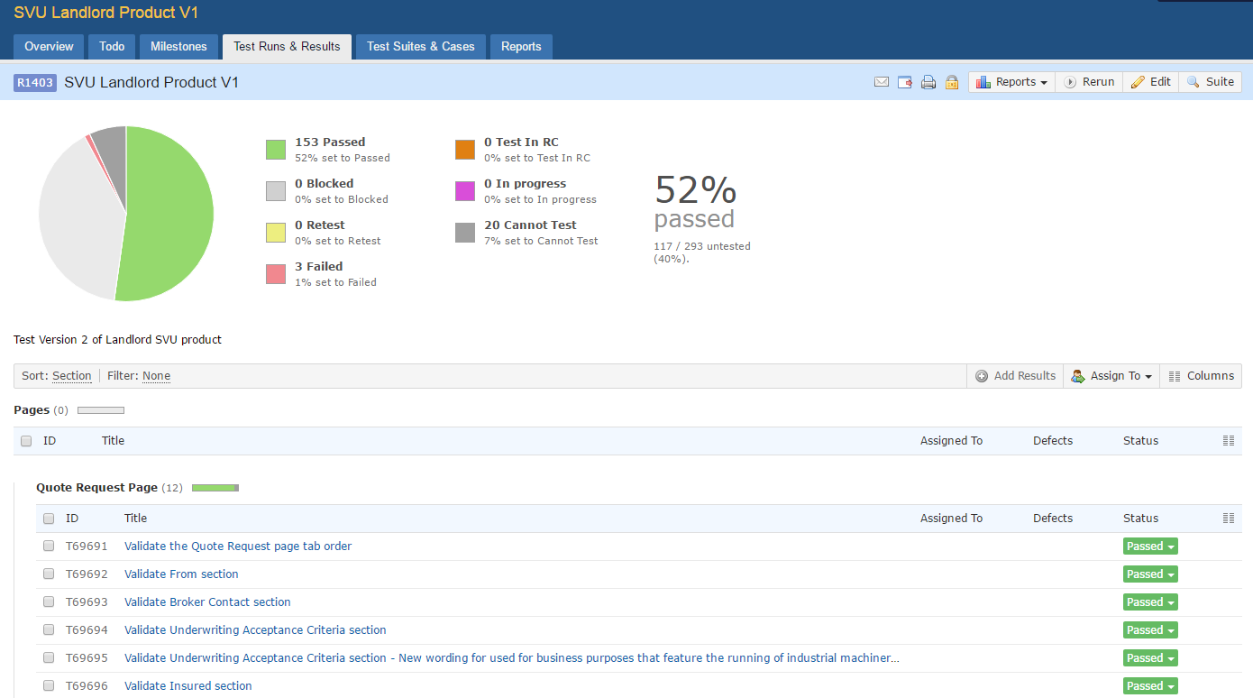

Actual results should be recorded at the test step level or test case level, with transaction references (if applicable), screenshots and other proof-of-test comments added where appropriate.

## Test Completion Report

The reporting features developed in the QA report tool will be used to produce test execution summary. Below is a sample snapshot of the report

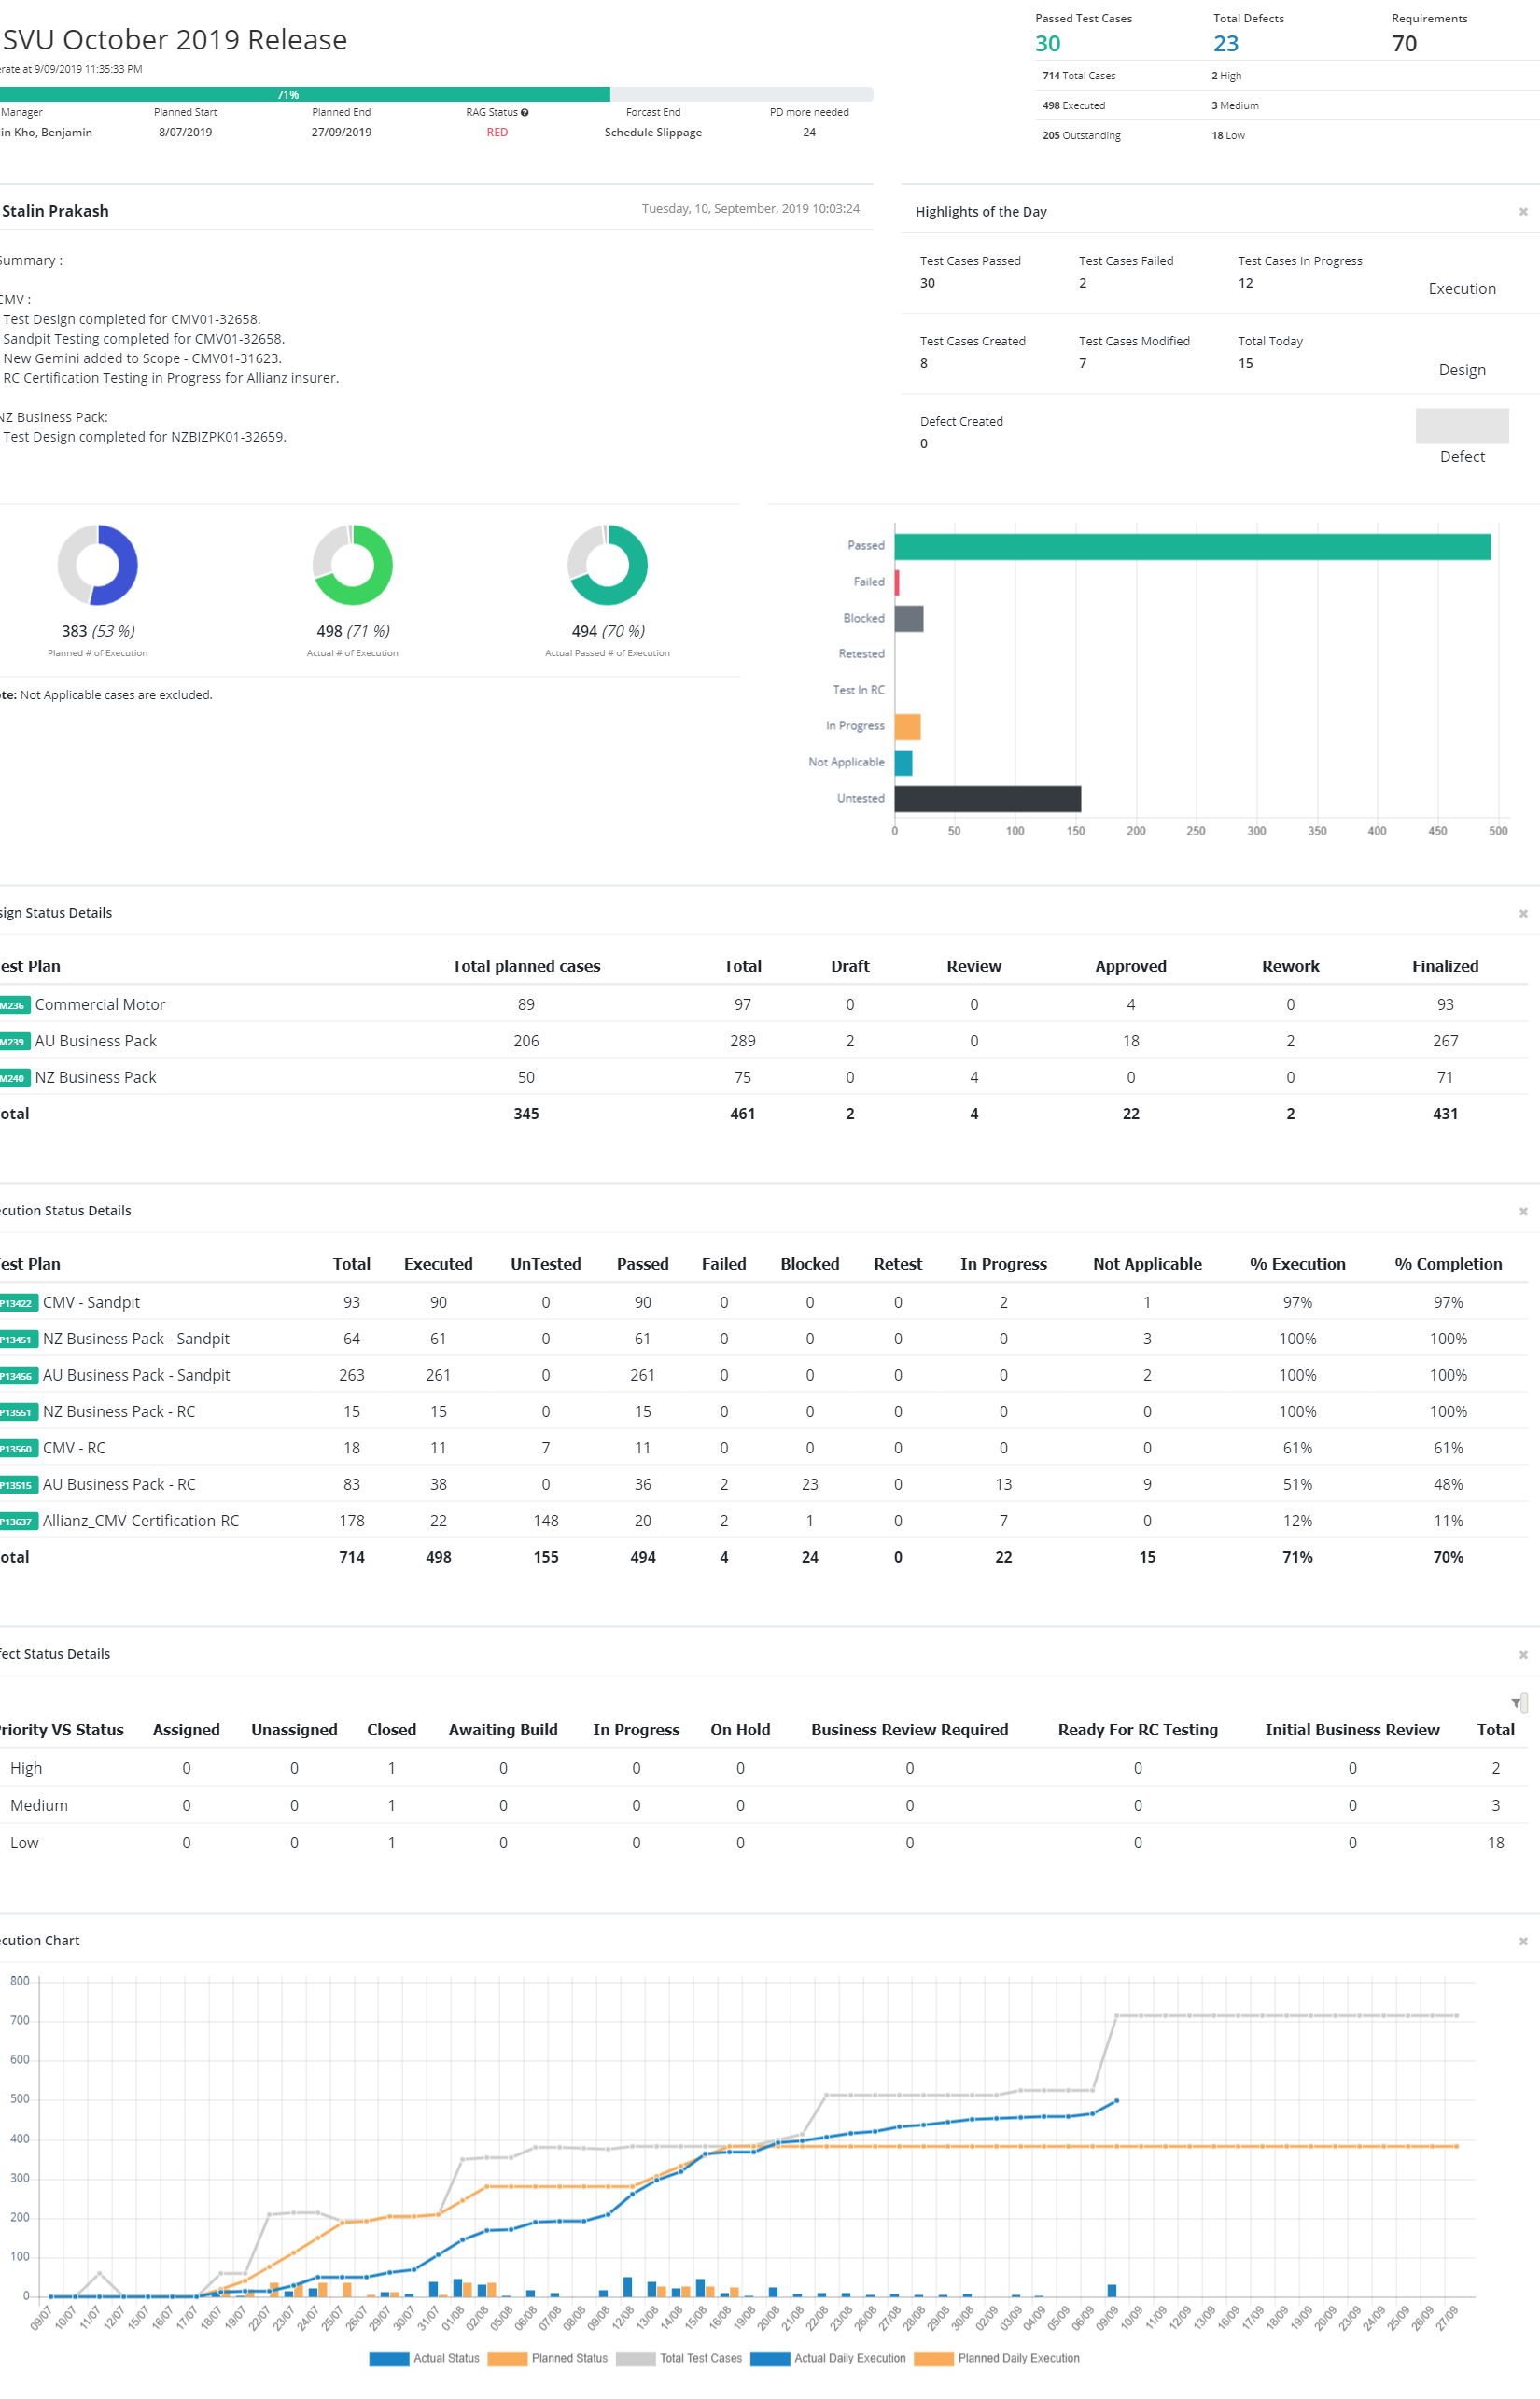

# Defects Management

Gemini will be used to log and track defects. Defects will be logged with the following details.

| Version | 6.6.0.4583 |
| --- | --- |
| Project(s) | NIRD |
| Component | Not Applicable |
| Type | Bug |
| Description | A description of the problem encountered with reproduction steps, and with screenshots/attachments as required |
| Source | System component the defect was identified in |
| Priority | Low/Medium/High |
| Resource | DEV / BA / IT PM |

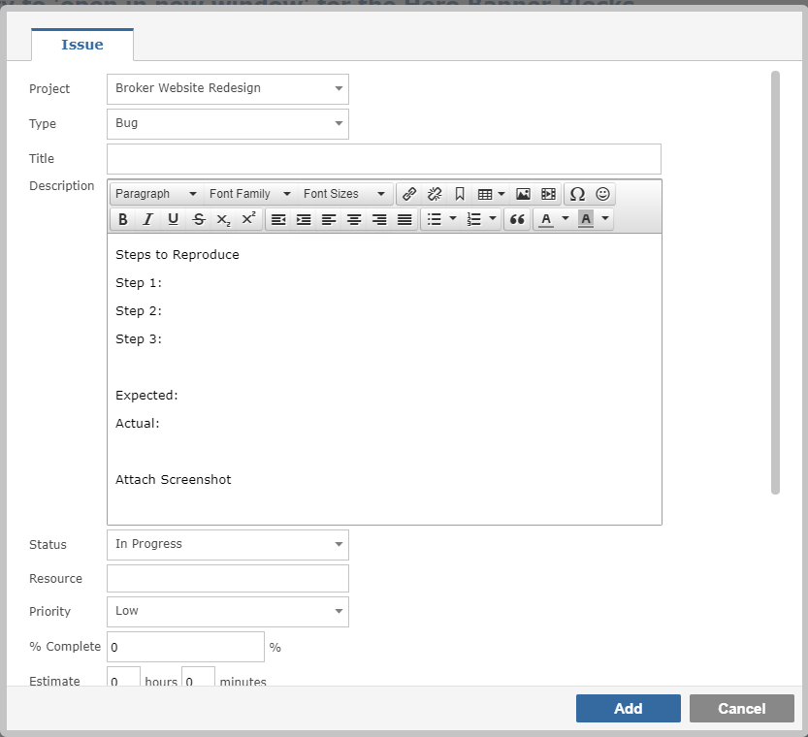

# Environment Requirements

The test environments used are:

|  |  |
| --- | --- |
| **Test Environment** | **Comments** |
| NIRD | Test environment |

## Tools

The following table lists the tools used by the QA team:

| **No.** | **Purpose** | **Tool** |
| --- | --- | --- |
| 1 | Defect management | [Gemini](https://intranet.steadfasthub.com/devjobs/workspace/0/items?projects=74) |
| 2 | Project management | [SharePoint](https://steadfastgrp.sharepoint.com/sites/Sitecore/Shared%20Documents/Forms/AllItems.aspx?viewid=f1cd255e%2D8bea%2D4062%2D833c%2D42ec97c0a29c&id=%2Fsites%2FSitecore%2FShared%20Documents%2FFY21%20%2D%201st%20Half%2FSUA%20Hub) |
| 4 | Test Management | [TestRail](https://steadfast.testrail.com/index.php?/dashboard) |
| 5 | Cross Browser Testing tool | <https://crossbrowsertesting.com> |

# Appendix A

## Defect Severity Definitions

|  |  |
| --- | --- |
| **Severity** | **Definition** |
| Showstopper | The defect affects critical functionality or critical data. It does not have a workaround. This defect must be resolved before the product is deployed into production |
| Major | The defect affects major functionality or major data. It has a workaround but is not obvious and is difficult. This defect must be resolved before the product is deployed into production |
| Minor | The defect affects minor functionality or non-critical data. It has an easy workaround. |
| Trivial | The defect does not affect functionality or data. It does not even need a workaround. It does not affect productivity or efficiency. It is merely an inconvenience. |

# Document Management

## Version Management

|  |  |  |  |
| --- | --- | --- | --- |
| **Version** | **Modification** | **Author** | **Date** |
| 0.1 | Initial Draft | Tien Thi Thuy Nguyen | 03/03/2021 |
| 0.2 | Review | Sofia Bry | 04/03/2021 |
|  |  |  |  |
|  |  |  |  |

## Distribution

|  |  |  |
| --- | --- | --- |
| **Name** | **Role** | **Action**  (Sign-off, Review, Information) |
| Nathan Hillery | Chief Information Officer | Information |
| David Boursnell | Operations Manager – Broker Distribution & Professional Services | Sign-off |
| Mitchell Koellner | Team Lead – Group Systems & Support | Sign-off |
| Sofia Bry | Project Manager | Review |
| Suzanne | Business Analyst | Review |
| Hao Chi Du | Developer | Information Only |

## Related Documents

|  |  |
| --- | --- |
| **Document Name** | **Document Location** |
| Project Brief | [Link to Project Brief](https://steadfastgrp.sharepoint.com/sites/Sitecore/Shared%20Documents/NIRD/1.%20INITATION/1.2%20PROJECT%20BRIEF/NIRD_Project_Brief_V0.3.docx?web=1) |
| Cyber Security Questionnaire | [Project Sharepoint link to form](https://steadfastgrp.sharepoint.com/:b:/r/sites/Sitecore/Shared%20Documents/NIRD/1.%20INITATION/Current%20Forms/Cyber%20Security%20Questionnaire%202019.pdf?csf=1&web=1&e=d82TKi) |
| Management Liability Form | [Project Sharepoint link to form](https://steadfastgrp.sharepoint.com/:b:/r/sites/Sitecore/Shared%20Documents/NIRD/1.%20INITATION/Current%20Forms/ML%20Prop%20.pdf?csf=1&web=1&e=Gp2Npz) |
| Steadfast Broker Website Style guidelines | [Broker Website SharePoint](https://steadfastgrp.sharepoint.com/:f:/r/sites/Sitecore/Shared%20Documents/Broker%20Website?csf=1&web=1&e=fGE85O) |

## Glossary

|  |  |
| --- | --- |
| Term | Explanation |
| CPD | Continuous Professional Development |
| CBT | Cross Browser Testing |
| IE | Internet Explorer |
| HTTP | Hypertext Transfer Protocol |
| QA | Quality Assurance |
| SIT | System Integration Testing |

END